Discover Diving 2021

A friendly, active club for all levels of snorkeller and diver

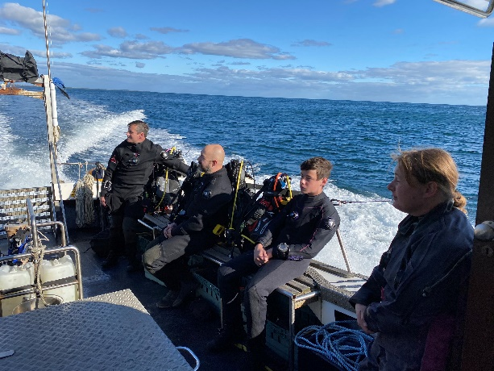
Why join the club?
- Regular dives throughout the year
- Diving to suit all levels of qualifications
- Find dive buddies to share your adventures
- Well-managed, organised diving and snorkelling
- A great range of benefits
  - Members’ rate for boat dives,
  - Members’ rate for gas fills,
  - Members’ rate for dive equipment hire
  - Members’ discount on training courses
  - 10% discount on all instore purchases

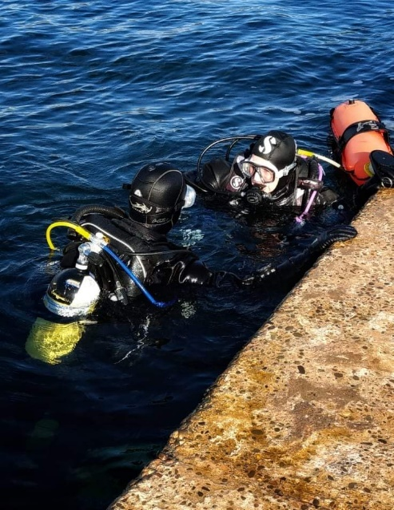
How do I join?
- Pick the membership category that best suits you (see the table on the next page).
- Fill in the form attached and bring it down (or post) with a cheque to Discover Diving, Marina House, Bay View Road, Port St Mary IM9 5AQ. We ask for a new form each year so we know we have updated Next of Kin information and contact information for you.
- Please include a completed medical self-declaration form (or copy of a medical referee signed form).
- If you want to sign up for the BSAC Direct Debit option which includes branch membership and BSAC membership, you will need to complete the section on your BSAC form too. Please pop into the dive centre. BSAC Direct Debits will be increased automatically.
- If you are a BSAC member, please include your membership number on your form.
- If you are not a BSAC member please include a copy of your current 3rd party Liability Insurance Policy.
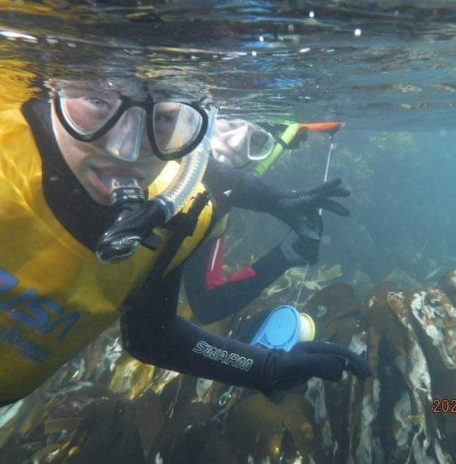
Membership year
- Membership can be renewed from November 1st 2020.
- Membership runs for a calendar year and expires on 31st December 2021.
- Membership after 1st August 2021 is offered at half year rate.

Anything else I should know?
- The club welcomes junior members and we expect adults to behave in an appropriate way when juniors are present.
- The Club is run as a Special Branch of BSAC (no committee and no politics)
- 3rd party liability insurance cover must be in place (BSAC members cover is standard, PADI divers should ensure they have separate liability cover in place)
- We will hold the information you give us for the purposes of administering your membership, benefits and diving/snorkeling activities. We will not disclose this information to Third parties unless required by law. We will delete any information on request.
- Membership benefits are not transferable to another person. If you are an elite member please just bring your own cylinders for your air-included fills.

Membership categories:

 | Snorkel members | Standard members | Elite members
Regular email
Members priority booking
Boat dive fees | £17.50 (save £12.50) | £25 (save £10) | £20.00 (save £15.00)
Equipment hire | ½ price | ½ price  (and ½ day rate) | ½ price  (and ½ day rate)
Training courses | 20% discount | 20% discount | 20% discount
Shop discount* | 10% off stock items | 10% off stock items | 10% off stock items
Gas fills | n/a | Special members rate | Air included  Nx/O₂/He @ member rates
Pool access
Cylinder testing fast track | n/a
Regulator servicing fast track | n/a
Summer wetsuit hire
Cost of annual membership | £80 | £150 | £300
Junior rates | £40 | £100 | £250
NB BSAC Membership is paid separately to the Branch membership.
* Shop discount excludes lead, cylinders and BSAC log books. Special order items are not included

Any other questions?
- Please ask in the dive centre
- Email us info@discoverdiving.im
- Find us on Facebook.
- Visit our website www.discoverdiving.im
- Call Michelle on 07624 300090

Club Membership Form 2021
Name
Address
Home telephone
Mobile telephone
Email
Date of birth
BSAC Membership number or PADI student number
Next of kin
Name
Relationship
Address
Telephone
Mobile Phone
Qualifications held & date obtained
Eg BSAC | Ocean Diver | July 2020
Insurance | BSAC | Other (please attach)
Medical form | YES/NO

Date of joining _________________

Membership category  (please indicate which  category applies) | Adult Elite | £300
 | Adult | £150
 | Junior Elite | £250
 | Junior | £100
 | Adult snorkel | £80
 | Junior snorkel | £40

